Chapter 17, Problem 11.

Obtain the exponential Fourier series for the signal in Fig. 17.54.

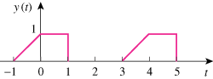

10

Figure 17.54
For Prob. 17.11.

